Dummy Scenario – Instructor Consultation Booking System
Oct 29, 2026 · @Md Alamgir Hossain
Note to team: This is a fictional practice scenario for drafting Deliverables 1–3 before the real interview. Replace it with Walter's actual system request once the interview is done.

1. The user
Walter Dvorak, Instructor, Technology Management / Business Information Systems (TM/BIS), Saskatchewan Polytechnic, Regina campus.
Main duties:
- Teaches 4–5 course sections per term, about 120–150 students in total
- Holds office hours and one-on-one consultations
- Supervises group projects, including scheduling interviews like this assignment's
- Grades work and posts results in D2L Brightspace
- Advises students on course and program questions
Systems he uses today:
- D2L Brightspace (course content, dropboxes, grades)
- Cengage MindTap (online assessments)
- Outlook email and calendar
- Microsoft Teams (online meetings)
- Excel (his own tracking sheets)
- A paper sign-up sheet on his office door

2. The system request (in Walter's words)
"Every term I lose hours just scheduling people. Students and project groups email me to book consultations. I reply with times, they reply back, and it goes back and forth three or four times. Some show up at the wrong time, some double-book, and I have no record of what we discussed. I'd like a simple system where students can see my open time slots, book a meeting themselves, get a reminder, and where I can keep short notes on each meeting."

3. System request form (Chapter 2 format)
Field | Entry
Requestor | Walter Dvorak, Instructor TM/BIS
Department | School of Business / TM-BIS Program, Regina campus
Date submitted | October 2026
Title of request | Instructor Consultation Booking System
Type of request | New system
Urgency | Medium. Wanted before the Winter 2027 term.
Problem description | Consultations are booked by email and a paper door sheet. This causes back-and-forth emails, double-bookings, missed meetings and no meeting records.
Reason for request | Save instructor time, improve service to students, keep a record of consultations.
Expected benefits | About 3–4 hours a week of scheduling time saved, fewer no-shows, a searchable meeting history, better student experience.
Constraints | Very small budget. Must work with Outlook/Teams and Sask Polytech student logins. Must protect student information under provincial privacy law (FOIP).

4. Current process
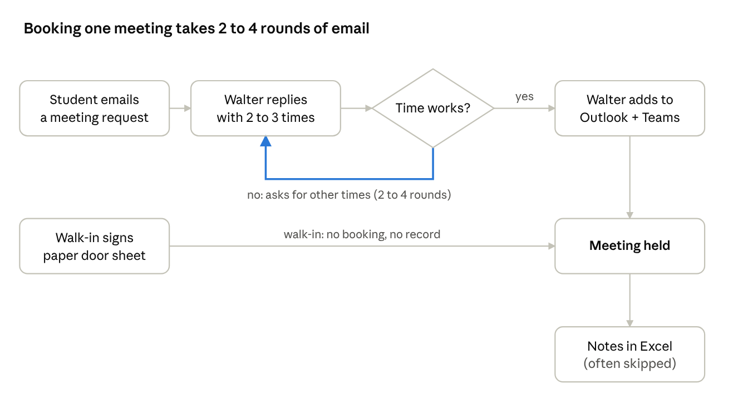
current booking process · 6 steps, 1 loop
Emailed requests loop between Walter and the student until a time works; walk-ins bypass the calendar entirely, and meeting notes are often skipped. Use this as the "as-is" process for the BPM or flowchart in Deliverable 1.

5. Problems with the current process (dummy numbers)
Problem | Impact
About 40–60 booking emails per week at peak times (midterms, project deadlines) | 3–4 hours a week of instructor time
Double-bookings between the paper sheet and Outlook | About 2–3 conflicts a month
No automatic reminders | Roughly 15% of booked meetings are missed
No central meeting record | Hard to track group project progress or follow up
Paper sheet is visible on the door | Privacy concern, since student names are posted publicly

6. Stakeholders
- Primary user: Walter (instructor)
- Other users: Students and project groups
- Indirect stakeholders:
  - Program head or chair (approval, and possible use by other instructors)
  - Sask Polytech IT Services (hosting, logins, security)
  - The privacy office (FOIP compliance)

7. CATWOE inputs (for Deliverable 1)
Element | Entry
Customers | Students and project groups
Actors | Walter and other instructors (later), plus IT support
Transformation | Booking requests made by email or paper become confirmed, self-booked meetings with reminders and records
Worldview | Instructors should spend their time teaching and advising, not scheduling
Owner | The TM/BIS program, School of Business
Environment | Small budget, the existing Microsoft 365 and D2L setup, FOIP privacy rules, a short term timeline

8. Dummy interview answers (for Deliverable 3)
# | Question | Walter's (dummy) answer
1 | What are your main responsibilities? | "Teaching, grading, advising, and supervising group projects across 4–5 sections."
2 | Which systems do you use daily? | "Brightspace, Outlook, Teams, MindTap and my Excel sheets."
3 | What's the biggest frustration? | "The email back-and-forth just to book a 15-minute meeting."
4 | How long are typical meetings? | "15 minutes for individuals, 30 minutes for groups."
5 | When do you hold office hours? | "Tuesdays and Thursdays, 1–3 pm. Other times by appointment."
6 | Must-have features? | "Show my open slots, let students book and cancel, send reminders, and give me a place for notes."
7 | Nice-to-have features? | "An automatic Teams link, and a way to see all meetings with one group."
8 | Who should see the meeting notes? | "Only me. Students only see their own bookings."
9 | Any budget or tool limits? | "Little to no budget. It should use what the college already has."
10 | How will you know it works? | "Fewer emails, fewer no-shows, and I can find any past meeting in seconds."
Second fact-finding technique (to meet the "two techniques" rule): a short student questionnaire. Dummy results from 30 responses:
- 80% said booking by email is slow
- 70% would prefer to self-book online
- 60% have missed or forgotten a meeting at least once

9. Ideas for the later deliverables
Feasibility (Deliverable 2):
- Operational: Walter and the students want it.
- Technical: It could be built on Microsoft Bookings or Power Apps under the existing Microsoft 365 licence, or as a small custom app.
- Economic: Low cost, and the 3–4 hours a week saved is worth roughly $X a term. The team can pick a dummy hourly rate.
GUI screens for the prototype (Deliverable 8):
- Student booking page with a calendar and open slots
- Booking confirmation
- Instructor dashboard with today's meetings
- Meeting notes screen

